Backtest location: Z:\ApolloGX\im_dev\backtest-main
TABLE OF CONTENTS
I. Purpose of Backtest
II. Backtest Main Steps
- Phase 1: Portfolio Configuration
- Phase 2: Data Acquisition
- Phase 3: Execution & Output
III. Advanced: Call Spread Construction
IV. Maintenance & Internal Logic

Editor | Date
Ricardo Jiao | 2025-12-19

I. Purpose of Backtest
The purpose of the backtest is to evaluate how covered-call ETFs or other options overlay strategies have performed historically, in order to assess whether these strategies warrant further consideration.
II. Backtest Main Steps:
- Portfolio Configuration
- Data Download
- Run Backtest
Portfolio Configuration:
File path: "Z:\ApolloGX\im_dev\backtest-main\runs\portfolio_configs.csv"
- Allocation: 10000000 means we have initial cash 10000000; 1 means we invest 100% our cash position into equity1 (SPY US); -0.5 means we sell option1 with 50% coverage ratio.
- Custom_options_file: it is the options list file we need to run the backtest. Such file will be generated along with the “Run Backtest” process ("Z:\ApolloGX\im_dev\backtest-main\runs\custom_options_list"). But we will need to input the file path at the Portfolio Configuration Step. The naming method is: runs\custom_options_list\{backtest} US_{pct_otm}_option_list.csv (replace US with CN if backtesting CN equity)
- DTM: Date to Maturity, it determines the dates we roll the options. It will +6 days and find the closest next Friday as rolling date. For example, if our start date is Monday, 12-15-2025, 6 means we will +6 days (12-21-2025) and find the closest next Friday (12-26-2025). Then +6 we go to (1-1-2025) and the closest Friday is (1-2-2025). So this is weekly rolling.
- Rebal_rule: Generate equity rebalance dates based on rule:
Q = Quarterly (3rd Friday Mar/Jun/Sep/Dec)
S = Semi-Annual (3rd Friday Mar/Sep)
A = Annual (3rd Friday Dec)
O = Same as option roll schedule (i.e. everytime an option is rolled, the portfolio is rebalanced)
Detailed code logic is in "Z:\ApolloGX\im_dev\backtest-main\helper_functions\rebalance_dates_customized.py"
- Target yield: if “-1”, it’s normal option rolling backtest. If input a target(like 0.15), then the backtest will run in the case we want to achieve specifically 15% annualized yield in every rolling.
Data Download:
Equity download: "Z:\ApolloGX\im_dev\backtest-main\data_download\bbg_equity_downloader.py"
Weekly US option download: "Z:\ApolloGX\im_dev\backtest-main\data_download\us_option_weekly_downloader.py"
Monthly US option download: "Z:\ApolloGX\im_dev\backtest-main\data_download\us_option_downloader.py"
TMX option download: "Z:\ApolloGX\im_dev\backtest-main\data_download\tmx_option_downloader.py"
Every time we run new backtest, we will need to download the data since they are likely not in our database. We need to download both options and equity data we want (Above are the python files to download the data)
Run Backtest:
File path: "Z:\ApolloGX\im_dev\backtest-main\run_targetpay.py"
This is the major file in the backtest. Run_targetpay includes one submajor file: "Z:\ApolloGX\im_dev\backtest-main\runs\create_custom_options_customized_tenor.py". It used to be two separate files. Now I combined them into one using the “build_custom_option_files” function in the major file to trigger the submajor file.
So basically the only thing you need to change is the backtestname. (See the comment in the same line for other potential changes)You will need to change it to the backtest you want to test in Portfolio Configuration.
Output files are in: Z:\ApolloGX\im_dev\backtest-main\output

III. Call Spread testing guides:
In above case, 10% of weight is 1x1 Long 80%/100% Call Spread, 90% of weight is long stock. To construct the call spread, we need to manually calculate the allocation in “?” since the original rules of the backtest don’t allow use to write option on an option.
The Calculation steps are as follows:
- 0.1 means we distribute 10% of our initial cash to buy 20% in the money call for leverage purpose. Take 12-18-2025 as example, SPY US price is 676, 20% in the money looks at the strike 540.
- Let’s check the price of the option expiring next week: SPY 12/26/25 C540 is 140.
1000000/140 = 7142.9, which means we can use 10% of our initial cash to buy 71 contracts.
- That being said, we need to write 71 contracts for at the money call to construct the call spread. Since we use 90% of initial cash to buy equity. It’s roughly 9000000/676=13313.6 shares of SPY.
- Therefore, the coverage ratio is 71*100/13314 = 0.53. So we input -0.53 in the “?”
The rest steps are exactly the same as normal backtest with the only difference that target_yield should always be -1 when you backtest the call spread.
Note: This calculation method does not ensure that the long and short legs of the call spread have exactly matching share equivalents at each roll. However, it is sufficient for backtesting purposes, as the goal of the backtest is to provide an intuitive and comparative understanding of how different options overlay structures behave over time, rather than to replicate exact trade-level execution.

IV. Maintenance & Internal Logic
Internal logic of Run Backtest Step:
The run_targetpay file links to two important files:
1. "Z:\ApolloGX\im_dev\backtest-main\runs\create_custom_options_customized_tenor.py".
( as we mentioned above)
In this option list generator, the most common issue is a mismatch between:
- the custom_options_file name specified in the portfolio configuration, and
- the Excel filename generated in Z:\ApolloGX\im_dev\backtest-main\runs.
For example:
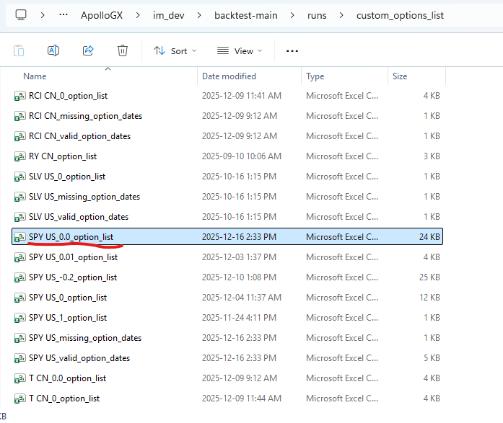
These two filenames must match exactly (including spelling, underscores, and file extension) for the backtest to run successfully.
2. "Z:\ApolloGX\im_dev\backtest-main\models\btbuilder_customized.py"
The btbuilder module contains the core logic governing options rolling and is the backbone of the entire backtesting framework. The run_targetpay script primarily functions as a trigger that calls this logic.
As a result, if the backtest breaks or new features need to be added, development work will most likely be implemented within btbuilder_customized.py, rather than in the run_targetpay script itself.
Most important functions in btbuilder_customized script:

run_portfolio_backtest(portfolio, start_date, end_date, rebal_dates, holidays, equity_rebal_rule, target_yield, reinvest_premium=False)
This is the main backtest engine. It simulates the portfolio day-by-day:
- Determines option roll dates and equity rebalance dates
- On roll/rebalance days:
  - Seeds cash at start
  - Closes old options / FX forwards (records cash inflow/outflow)
  - Optionally rebalances equities
  - Opens new option positions (writes/buys) based on config and target-yield logic
  - Optionally reinvests premium into equities
  - Applies FX hedges if configured
- On non-roll days:
  - Updates prices/FX, accrues dividends into cash via synthetic “reinvest” trade
- Appends daily holdings into a detailed DataFrame
Returns:
- output_summary (from daily_returns)
- output_detailed (security-level holdings over time)
- plus coverage dict if target_yield != -1
Other functions in btbuilder_customized script:
- daily_returns: Aggregates security-level market values into portfolio-level daily returns, cumulative returns, and drawdown metrics.
- compute_target_allocation: Estimates the option coverage/allocation needed to achieve a target premium yield using the option mid-price and underlying equity size.
- cashflow_period_report: Summarizes performance attribution between roll dates by decomposing returns into basket, option premium, buyback, dividends, and other effects.
- equity_correlation_matrix: Computes the average pairwise correlation of equity returns over a specified date range.

